Assignment -3

Bucket And Watson assistant

|  |  |
| --- | --- |
| Assignment Date | 26 October 2022 |
| Student Name | KIRTHIKA K |
| Student Roll Number | 713319CS065 |
| Maximum Marks | 2 Marks |

Questions:

1. Create a Bucket in IBM object storage.

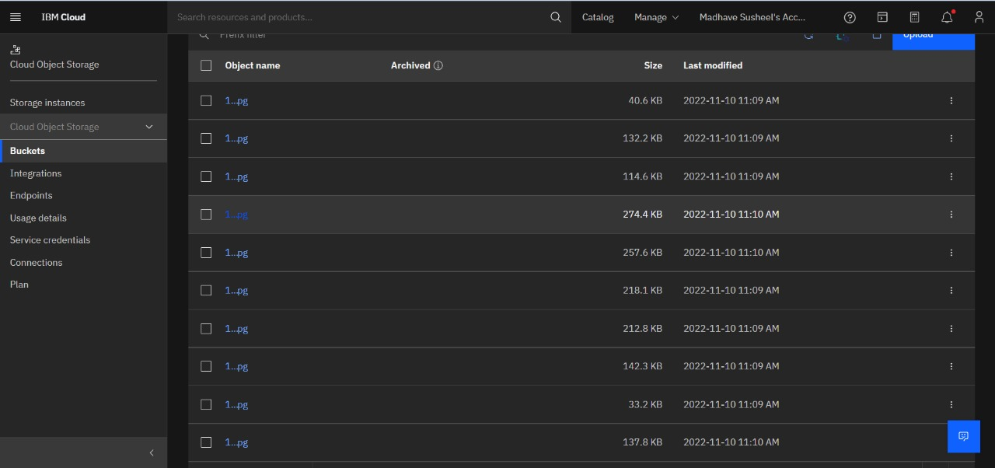

1. Upload 5 images to IBM object storage and make it public. write html code to displaying all the 5 images.

Index.html

|  |
| --- |
| {%for i in range(0, len)%}                      <div class="col-lg-4 col-md-6 col-sm-12 pb-1">                          <div class="card product-item border-0 mb-4">                              <div class="card-header product-img position-relative overflow-hidden bg-transparent border p-0">                                  <img class="img-fluid w-100" src="{{imagearr[i]}}" alt="">                              </div>                              <div class="card-body border-left border-right text-center p-0 pt-4 pb-3">                                  <h6 class="text-truncate mb-3">{{pro_name[i]}}</h6>                                  <div class="d-flex justify-content-center">                                      <h6>{{pro_price[i]}}</h6><h6 class="text-muted ml-2"></h6>                                  </div>                              </div>                              <div class="card-footer d-flex justify-content-between bg-light border">                                  <a href="" class="btn btn-sm text-dark p-0"><i class="fas fa-eye text-primary mr-1"></i>View Detail</a>                                  <a href="" class="btn btn-sm text-dark p-0"><i class="fas fa-shopping-cart text-primary mr-1"></i>Add To Cart</a>                              </div>                          </div>                      </div>                        {%endfor%} |

1. Upload a css page to the object storage and use the same page in your HTML code.

Output:

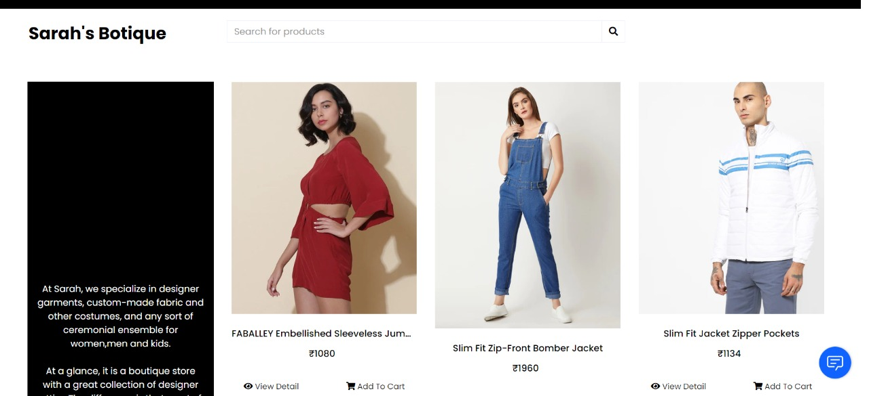

4.Design a chatbot using IBM Watson assistant for hospital. Ex: User comes with query to know the branches for that hospital in your city. Submit the web URL of that chat bot as a assignment.

Url :- [chatbot link](https://web-chat.global.assistant.watson.appdomain.cloud/preview.html?backgroundImageURL=https%3A%2F%2Feu-gb.assistant.watson.cloud.ibm.com%2Fpublic%2Fimages%2Fupx-2187bdc6-3463-4336-a0e5-105ac4d979db%3A%3A31897cd3-e620-4527-80d8-c93d7c618899&integrationID=fd3649a9-27f7-43a9-96c0-5ca4d5bbf885&region=eu-gb&serviceInstanceID=2187bdc6-3463-4336-a0e5-105ac4d979db) <- click

Image-

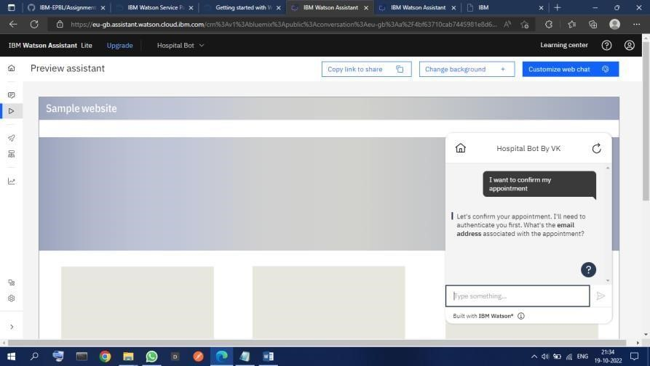

1. Create Watson assistant service with 10 steps and use 3 conditions in it. Load that script in HTML page

